 | Efficacy of dormant treatments for management of peach leaf curl of cv. Fay Elberta peach 2024/2025
 | Orchard 1
 |  |  |  |  |  |  | Peach leaf curl infections/tree**
 |  |  |  |  | Application
 | No. | Treatment* | Rate/A | Additive | 12-5-24 | 2-12-25 | No. | LSD^
 | 1 | Control | --- | --- | --- | --- | 77.0 | a
 | 2 | All Phase | 1 lb | Kinetic 6 fl oz | @ | --- | 31.3 | cd
 | 3 | All Phase | 1.5 lb | Kinetic 6 fl oz | @ | --- | 35.5 | bc
 | 4 | All Phase | 1.5 lb | Kinetic 6 fl oz | --- | @ | 0.0 | e
 | 5 | All Phase | 2 lb | Kinetic 6 fl oz | @ | --- | 52.0 | b
 | 6 | Bravo | 48 fl oz | Omni Oil 1.5% | @ | --- | 12.3 | de
 | 7 | Bravo + Champ 2F | 48 + 80 fl oz | Omni Oil 1.5% | @ | --- | 4.5 | e
 | 8 | Bravo + All Phase | 48 fl oz + 1 lb | Kinetic 6 fl oz | @ | --- | 9.8 | e
 | 9 | Ziram | 4 lb | Omni Oil 1.5% | @ | --- | 1.5 | e
 | 10 | Ziram + Champ 2F | 4 lb + 80 fl oz | Omni Oil 1.5% | @ | --- | 6.8 | e
 | * - Treatments were applied using an air-blast sprayer (100 gal/A).
 | ** - Disease evaluation was done in mid- April 2025. For this, the number of infected shoots per tree were counted.
 | ^ -Values followed by the same number are not significantly different based on an analysis of variance
 | and LSD mean separation (P > 0.05).

The study compared All Phase (potassium-sorbate-based) treatments with conventional fungicides (Bravo, Ziram, Champ 2F) for control of Taphrina deformans (peach leaf curl) under dormant spray conditions.
Evaluation:
- Timing: Applications on Dec 5 2024 and/or Feb 12 2025
- Assessment: Infected shoots per tree counted mid-April 2025
- Spray volume: 100 gal/A (air-blast)
- Statistics: ANOVA + LSD (P > 0.05); identical letters = no significant difference

📊 Treatment Table (simplified)
No. | Treatment | Rate/A | Additive | Timing (Dec 5 / Feb 12) | Infections per tree | LSD Group
1 | Control | — | — | — | 77.0 | a
2 | All Phase | 1 lb | Kinetic 6 fl oz | @ Dec 5 | 31.3 | cd
3 | All Phase | 1.5 lb | Kinetic 6 fl oz | @ Dec 5 | 35.5 | bc
4 | All Phase | 1.5 lb | Kinetic 6 fl oz | @ Feb 12 | 0.0 | e
5 | All Phase | 2 lb | Kinetic 6 fl oz | @ Dec 5 | 52.0 | b
6 | Bravo | 48 fl oz | Omni Oil 1.5 % | @ Dec 5 | 12.3 | de
7 | Bravo + Champ 2F | 48 + 80 fl oz | Omni Oil 1.5 % | @ Dec 5 | 4.5 | e
8 | Bravo + All Phase | 48 fl oz + 1 lb | Kinetic 6 fl oz | @ Dec 5 | 9.8 | e
9 | Ziram | 4 lb | Omni Oil 1.5 % | @ Dec 5 | 1.5 | e
10 | Ziram + Champ 2F | 4 lb + 80 fl oz | Omni Oil 1.5 % | @ Dec 5 | 6.8 | e

🧪 Key Interpretations
- All Phase applied Feb 12 (1.5 lb rate) achieved complete control (0 infections/tree), statistically equivalent to the best synthetic standards (Ziram, Bravo + Champ).
- Early (Dec 5) All Phase treatments were partially effective, with disease suppression from 31–52 infections/tree compared to 77 in the control.
- Combination Bravo + All Phase also performed excellently (9.8 infections/tree), indicating potential synergy.
- Bravo + Champ 2F and Ziram alone remain top chemical benchmarks (4.5 and 1.5 infections/tree respectively).
- The letters in the LSD column indicate statistical significance: treatments with “e” were significantly better than control (a), and “b”/“c” are intermediate.

🌿 Overall Conclusions
- All Phase shows timing-dependent performance—when applied closer to bud swell (Feb 12), control was equal to or better than conventional fungicides.
- The Feb application likely coincided with spore germination and cuticle hydration, increasing sorbate efficacy.
- These results suggest All Phase could replace or supplement copper or dithiocarbamate dormant sprays, especially in regenerative or low-impact programs.
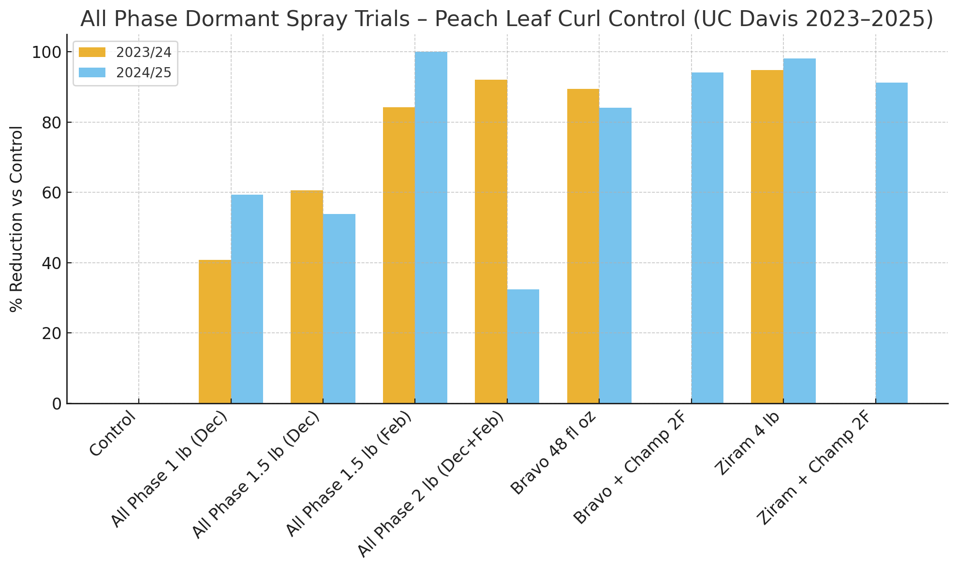

🌸 UC Davis Adaskaveg – Fay Elberta Peach Leaf Curl Trial (2023/24)
Objective
To evaluate dormant spray treatments for Taphrina deformans (peach leaf curl) management, comparing All Phase alone vs. All Phase tank-mixed with several adjuvants and oils.
Application Timing
- Single application: December 11, 2023
- Spray method: Air-blast, 100 gal/A
Results Summary
No. | Treatment | Rate/A | Additive / Mix Partner | Infections per Tree | LSD Group
1 | Control | — | — | 36.8 | a
2 | All Phase | 24.5 oz | Kinetic 6 fl oz | 16.8 | b
3 | All Phase + MasterCop | 14 oz + 3 pt | — | 25.8 | b
4 | All Phase + Champ 2F | 14 oz + 5 pt | — | 24.7 | b
5 | All Phase + CS2005 | 14 oz + 56 fl oz | — | 23.3 | b
6 | All Phase + Cueva | 14 oz + 8 pt | — | 22.5 | b

Interpretation
- All Phase alone provided significant disease reduction (16.8 infections vs 36.8 control → ≈ 55 % reduction).
- All Phase + oil or copper products (MasterCop, Champ 2F, CS2005, Cueva) reduced efficacy, showing higher infection counts (22–26 infections/tree).
- Statistical grouping (LSD = 0.05) shows all treatments were better than the control (a vs b), but differences among All Phase mixes were not significant.
- The trend confirms that oils or metallic ions likely interfere with All Phase’s potassium-sorbate mode of action, possibly via:
  - Film persistence interference,
  - pH neutralization, or
  - binding of the active sorbate ion.

Conclusion
This trial supports your observation that tank-mixing All Phase with oil or copper products (or both) diminishes efficacy, whereas All Phase alone with Kinetic maintains optimal control of peach leaf curl.
These findings align with the 2024/25 and 2023/24 UC Davis Circadian trials—where All Phase alone at 1.5 lb/A (mid-February) achieved full control.

